Homework 3: Structure Problem

- Please design a program to process the records of the students. The format of the record is the following:

name  20 characters | id  7 characters | chinese  int | english  int | math  int | total  int

(a). Please write an input function to input each record of the student.

(b). Please sort the record in ascending order according to the “total” field. If there are two or more records all have the same values of “total”, then compare the score of the chinese, if the scores of the chinese are the same then compare the score of the english , math. If still get the same, then output according to their Id.

- Write a menu-driven program that depicts the workings of a library.
The menu options should be:
- Add book information
- Display book information
- List all books of given author
- List the title of a specified book
- List the count of books in the library
- List the books in the order of catalog number
- Exit
Create a structure called “book” to hold the catalog number, title of the book, author name, price of the book, and flag indicating whether the book is issued or not.
You need to test your program use at least 20 books information.

Note: 此題是為圖書館 “編輯圖書目錄者” 設計的程式
不是圖書館 “借還書”的程式

3. A point in a plane can be represented by two coordinate, x and y.
Therefore, we can represent a point by a structure having two fields.
As shown below: struct Point
{ int x;
int y;
};

Write a function named “quadrant” that accepts a structure of type Point as parameter and returns an integer: 1 or 2 or 3 or 4 that indicates in which quadrant the point is located, as shown below:
x y
I positive positive
1

3 4
I I negative positive
III negative negative
IV positive negative

4. circle is an object can be specified by one point and radius
As shown below:

‧(x1,y1)
radius
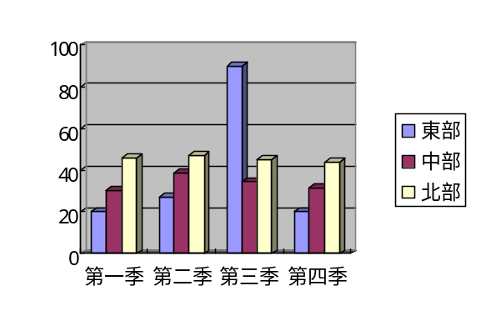
radius

Therefore, we can represent a circle by a structure having two fields,one for(x1,y1), one for radius.

(a). Please write the definition of struct Circle (by using struct Point.)
(b). Write a function named “area” that accepts a structure of type Circle as parameter and return the area of the circle.

5. An image can be treated as two-dimensional array whose elements represent
the pixels of the image. Image-editing programs often need to rotate an image by 90. For example, the rotation of the original image (i.e., p[M][N]) to the right produces a new image(i.e., r[N][M] ).
That is the first row of the original image becomes the last column of the new image, the second row becomes the last but one column, up to the last row, which becomes the first column.
For example, the image

P=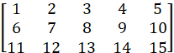 is transformed to R= 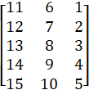

The color of each pixel follows the RGB color model, in which the red, green, and blue colors are mixed together to reproduce a wide range of colors. The color is expressed as an RGB triplet(r, g, b), in which each component value varies from 0 to 255.

Step1: Define the structure type “pixel” with three integer fields named red,
green, and blue.
Step2: Write a main program that creates two 2-dimensional images (i.e., 3x5)
Whose elements are structures of type “pixel”.
One called “img”, the other called “tmp”
Step3: For the “img”:
Initialize the fields of each pixel with random values within [0,255],
Then, the main program should display the original image “img” .
Step4: Write a function to rotate the “img” by 90 degrees right to “tmp”.
Display the rotates image“tmp” in the main program.

加分題可不寫.
6. We can represent “point”, “line”, “circle”, …, “polygon” in structure forms.
Please define all structure types and functions as you need, combine these figures to form one picture and draw it out on the screen.

7. Write a function that shuffles a deck of cards. The deck of cards is
represented by an array of 52 elements. Each element in the array is a
structure for one card, as shown below.
enum suit ‧‧‧ //clubs, diamonds, hearts, spades
struct Card
{ suit cardSuit;
unsigned int value //Ace, 2‧‧10, Jack, Queen, King
};
Card deck[52];

The function must use a random number to ensure that each shuffle results in a different card sequence. Hint: Generate a random number in the range of 1…52 and then exchange the current card with the card in the random position.
Please write a main program to test the function.

